**CITC-1301 Introduction to Programming**

**Chapter 1 Lab**

## Exercise 1: Using the Python Interpreter

To make sure you can interact with the Python interpreter, try the following steps on your computer:

1. Start the Python interpreter in interactive mode by typing "*Python 3*" in the Windows search box. Click the "*Python 3.# (64-bit)*" application in the search results.
2. At the >>> prompt, type the following statement, then press the [ENTER] key:

print("This is a test of the Python interpreter.") [ENTER]

1. After pressing the [ENTER] key, the interpreter will execute the statement. If you typed everything correctly, your session should look like this:

>>> print("This is a test of the Python interpreter.")

This is a test of the Python interpreter.

>>>

1. If you see an error message, enter the statement again, and make sure you type it exactly as shown.
2. Take a screenshot of the window using ALT+PRINTSCREEN key. Paste the screenshot below step 6.
3. Exit the Python interpreter. In Windows, press CTRL+Z followed by the [ENTER] key. On other systems, press **CTRL+D**. 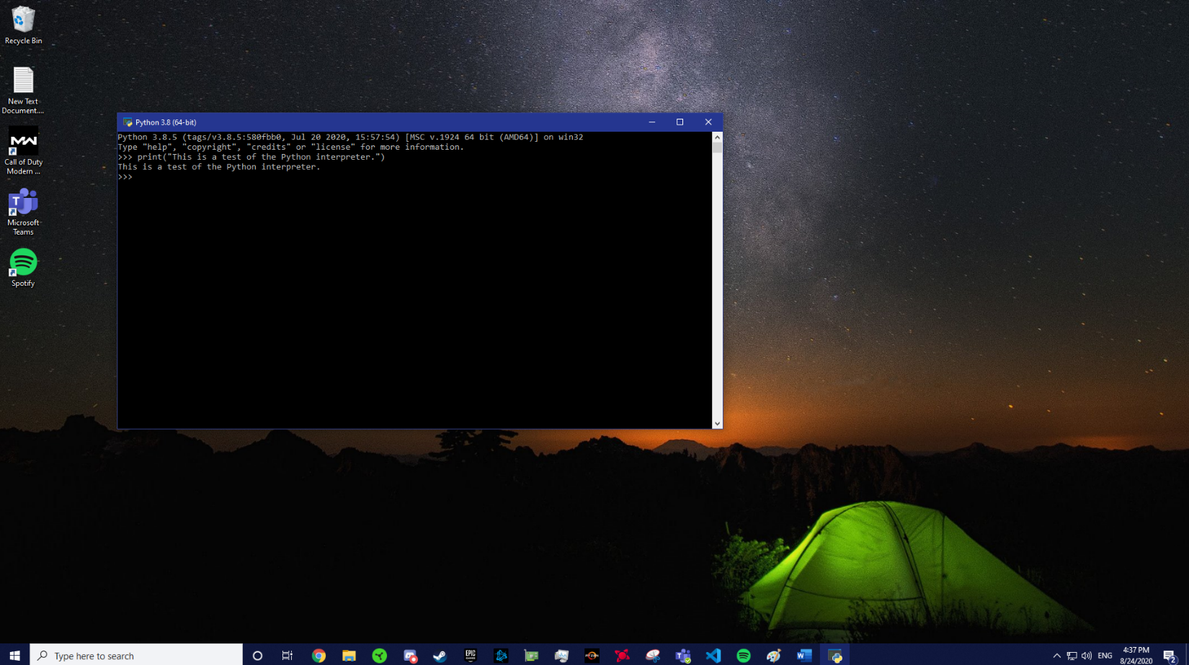

## Exercise 2: Decimal to Binary

Use what you've learned about the binary numbering system to convert the following decimal numbers to binary:

|  |  |
| --- | --- |
| Decimal | Binary |
| 11 | 1011 |
| 65 | 1000001 |
| 100 | 1100100 |
| 255 | 11111111 |

## Exercise 3: Binary to Decimal

Use what you've learned about the binary numbering system to convert the following binary numbers to decimal:

|  |  |
| --- | --- |
| Binary | Decimal |
| 1101 | 13 |
| 1000 | 8 |
| 101011 | 43 |
| 10110110 | 182 |

## Exercise 4: Binary to Decimal

Look at the ASCII character chart in Appendix C of *Starting out with Python, 4th Edition*. Determine the codes for each letter of your first name.

|  |  |  |  |  |  |  |  |  |  |  |  |  |  |  |  |  |  |  |  |  |  |  |  |  |  |  |  |  |  |  |  |  |  |  |  |  |  |
| --- | --- | --- | --- | --- | --- | --- | --- | --- | --- | --- | --- | --- | --- | --- | --- | --- | --- | --- | --- | --- | --- | --- | --- | --- | --- | --- | --- | --- | --- | --- | --- | --- | --- | --- | --- | --- | --- |
| |  |  | | --- | --- | | Letters | ASCII Code | | M | 77 | | A | 65 | | R | 82 | | K | 75 | | |  |  | | --- | --- | | Letters | ASCII Code | | N | 78 | | I | 73 | | C | 67 | | H | 72 | | O | 79 | | L | 76 | | A | 65 | | S | 83 | |  |  | |  |  | |  |  | |  |  | |

**Submission Instructions**

* Upload this document to the appropriate dropbox on eLearn.